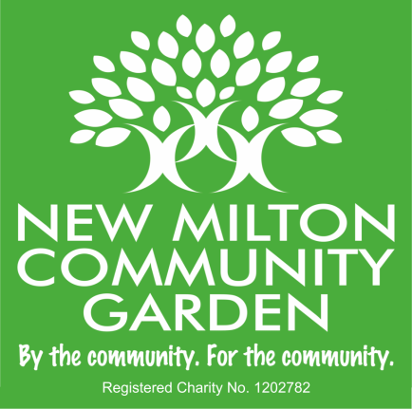

Community Garden News
A lot has been happening since last month! We are delighted to share the good news that our funding applications to the Charles Burnett Memorial Fund and the National Lottery Awards for All Fund were both successful. We have been granted £10,000 from each which is a huge relief as we were about to run out of money. These grants will now enable us to push forward with so much that needs to be done at the garden, including improving the surface area, creating more planting beds, acquiring trees, shrubs, climbers etc., providing good seating, attractive arches for entrance areas, and so much more. The grants from these significant organisations are a fantastic endorsement of the importance of the project for our community and something of which to be very proud.
We had a very busy and productive team meeting on 11th October, with many aspects of the project covered and discussed. We welcomed our new Minutes Secretary, Katrina Judson, and Alan Watson, our new Trustee. Louise Beardmore, NMTC Youth Services Mgr, also joined us as we have now had confirmation that both the Eaglewood and Arnewood schools will be including the community garden as part of the educational programme for some of their pupils. Perhaps encouraging and enthusing our young people to learn new skills and take up jobs in the horticultural/agricultural/forestry sector, which are much needed. Interest from many other groups and individuals continues to grow and we are doing our best to keep up with demand!
On that note, we are looking for more team members to join us to help take the project forward. Do you have an interest in horticulture, wildlife or helping your community? Perhaps you have skills or experience in admin, event management, social care, building things, media or communications? A project like this has many different aspects, it’s not just all about plants, it’s all about helping people to improve health & wellbeing, combatting loneliness, making friends, social engagement, growing their own food and just enjoying all the benefits of being in nature. Please get in touch, we would love to hear from you.
We have now set dates to plant the 400+ hedging whips being donated by the Woodland Trust to create a wildlife friendly hedgerow boundary around the garden. Join a friendly team on Tuesday 21st November and Wednesday 22 November, between 10am and 3pm. No heavy digging required, just bring a spade to create a slit in the soil and we will show you the rest. Minimal effort required! Please let us know which day(s) you can make and we look forward to seeing you.
Thank you everyone.
Email: newmiltoncommunitygarden@gmail.co,
https://www.facebook.com/newmiltongarden

