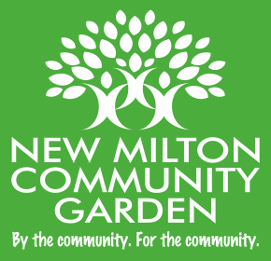 Registered Charity 1202782

***Community Garden News***

We are pleased to let you know that Phase 1 of the garden build is now complete and looking good. The path has been relaid and edged and the gazebo completed.

Our next team meeting is scheduled for 11th October when we will be focusing on Phase 2 of the build to get the garden ready for planting and our plans for the ongoing management of the community garden. We would like to thank the Woodland Trust for their donation of 420 hedging whips which will be used to create a hedgerow around the boundary of the garden. Hedgerows have suffered a steep decline in our country for many years and are necessary for the protection and preservation of wildlife. We are proud to be doing our bit to counteract this.

The hedging is due for delivery around the middle of November, which is ideal planting time, and we will need as many people as possible to help get them in the ground. If you haven’t done so already please get in touch to add your name to our volunteer list, we need you! We are a friendly bunch so come along, join in the community spirit, make new friends and enjoy making a difference. We will get in touch nearer the time to let you know the dates for planting.

Our thanks go to the Town Council for their continued support. They have confirmed that a new path is to be constructed across the Moore Close field up to the community garden very soon and that the heritage apple tree orchard next to the garden will be planted this season. The new development to build extra houses at Moore Close itself has recently started and is due to be completed by the autumn of next year, when a new line of native British trees and shrubs will be planted along the boundary at the rear of the community garden.

We are eagerly awaiting the results of our funding applications to the Charles Burnett Memorial Fund and to Awards for All. These funds are urgently needed to help us continue our good work and to make the garden all that it should be. Our sponsorship programme continues so if you, someone you know, or a local business you know of can help us then please get in touch and we can send you the details.

Our search for a Minutes Secretary has hopefully been successful and this will be of real help at our team meetings. We are also delighted to report that Alan Watson will be joining our team as a new trustee.

Until recently Alan was Chair of the New Milton Residents’ Association for many years and he has been a great supporter of our project from the very beginning. Alan (aka Mr. New Milton!) brings with him a wealth of knowledge of many local organisations and groups and his contribution will be of significant help and support. We thank Alan and look forward to welcoming him to our team.

If you would like to know more about us, the project, or importantly would like to help us in any way you can, please get in touch.

Thanks & best wishes, Julia (Chair of Trustees)

[newmiltoncommunitygarden@gmail.com](mailto:newmiltoncommunitygarden@gmail.com)

<https://www.facebook.com/newmiltongarden>