INDIAN MEMORIAL – PROPOSED FLAGPOLE

Following a request from The Friends of The Indian Memorial at the last Amenities Committee meeting on 12th April 2022 for the Town Council to consider a flagpole to be sited at an appropriate location by the Indian Memorial at Barton on Sea, it was agreed that consideration would be given to the request subject to any planning implications and the project fully costed.

Though the land is maintained by the Town Council, it is leased to us from NFDC so permission maybe needed from them to site the flagpole.

Two sizes of flagpole are suggested, 5m or 6m (the lamp columns adjacent are 6m as shown in the pictures below). It is strongly recommended that given the proximity of the sea and winds that a glass fibre option should be chosen within internal halyard (this is less prone to vandalism and reduces wind noise).
The pole should be mounted on a hinged base plate with a ground root set in concrete below ground.

The cost of a 6m flagpole including installation and delivery would be £775.00.
Below are two possible locations (centre of grassed area in yellow or right of the information board in red) for the siting but the final placement would need to be agreed.

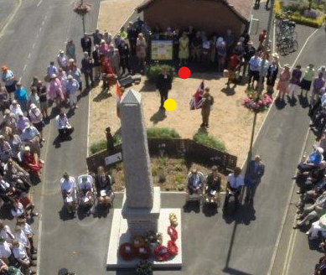

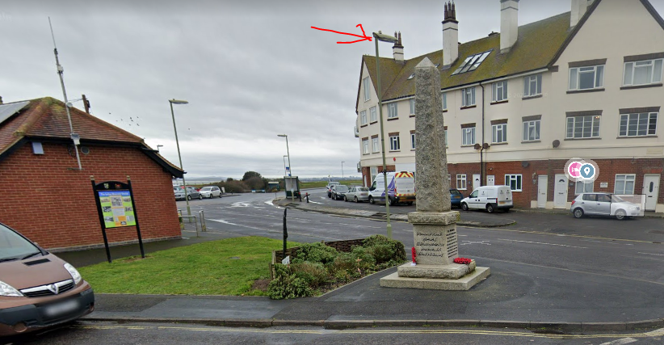

Picture showing 6m lamp column similar in height to the proposed flagpole in context to the surrounding area.

With regard to planning, NFDC have been approached and below is their positive response.
If given the go ahead and subject to funding, the flagpole could be in place for the July Remberance day.

