POORLY MAINTAINED STRIP OF LAND SOUTH EAST CORNER OF ASHLEY ROAD/STATION ROAD (KFC)

Despite the former NatWest site being fully occupied again, the unkempt land adjacent to it which forms part of the site as had little work carried out to improve the appearance nor does there appear little desire to do so. Given that this area is one of the main focal points of the town it was agreed to seek permission from the Land Agents for the Town Council to improve and maintain this unsightly strip. The search proved difficult as some key contact personnel had left the business, however Howard Roddis, Asset Manager for the Station Road site was located, contacted and he responded positively as below.

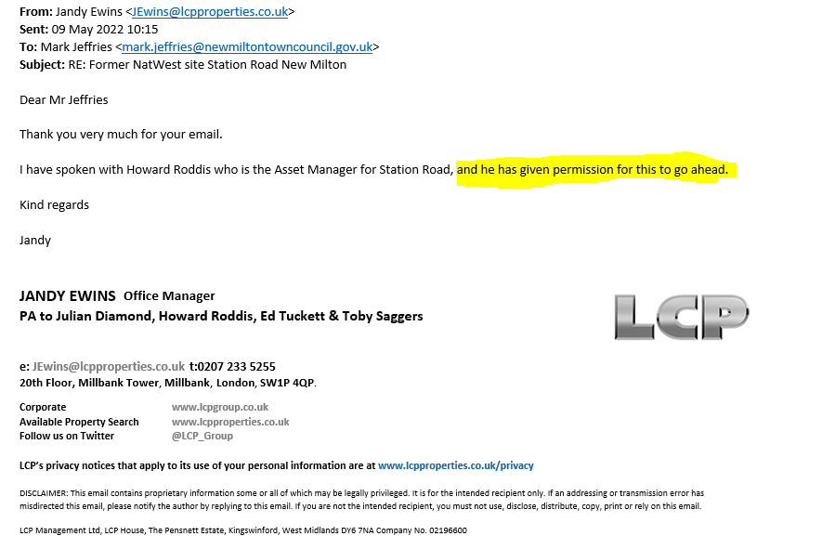

With permission granted the Town Council could initially carry out improvements that would be almost immediately effective but not too costly.
It is proposed that some simple levelling is carried out, the area is strimmed to ground level and geotextile membrane is applied to the existing surface which will be tied in to the existing surrounds and pegged down with plastic ground spikes. The whole of the geotextile can then be covered with 100 to 150mm of top soil which would be levelled and prepared for planting. For this first summer the area should be planted with annual bedding bringing instant colour to this drab piece of land, then in autumn the bedding can be removed and replaced with permanent low maintenance ground cover planting (hardy Phlox, Sedum, Creeping Thyme and hardy geraniums to name but a few). Up to five new trees could be planted with the cost of these covered either by the Resident Plant a Tree Scheme or by the Town Councils own tree replacement policy.
The cost for this improvement is relatively modest at around £2,500 (excluding trees) with some annual minor maintenance being required but the cost of this would be no more than £300 per annum. The improvements could be covered from the floral display/SLA budgets or ideally from non-sponsored contributions.
Below are photographs of the area now and what it could look like.

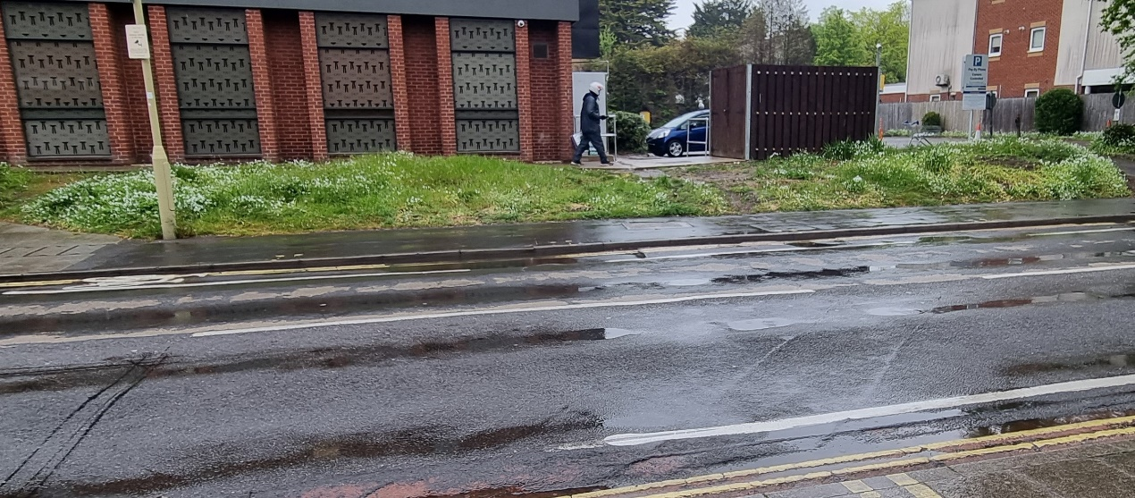
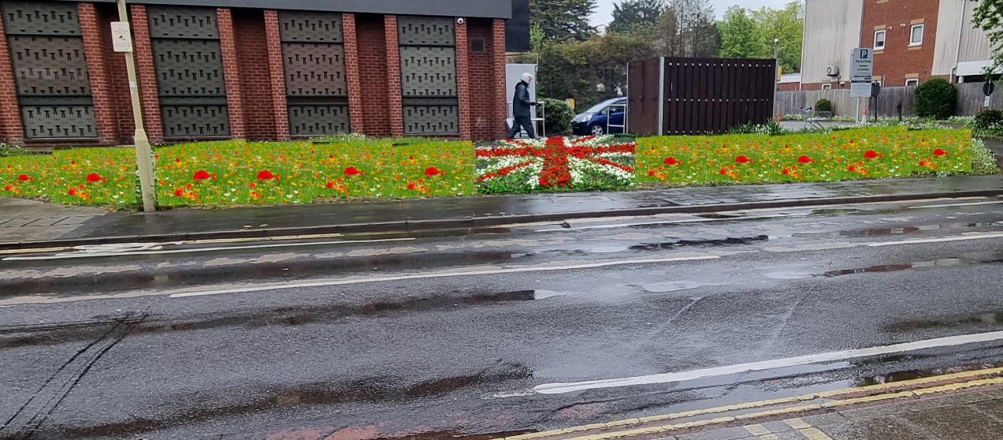
Current state of the strip of land.
An example of how it could look after improvement works.

