Christmas Lighting Display 2021-22
2021 was a contract renewal year and SparkX Ltd were the successful tender. SparkX have done well to maintain a good level of service with a decreasing team due to illness. We thank them for their efforts in what was a rather wet display season!
Going into this season we had a health-check of the lamp columns which returned quite a number of regularisation issues. The worst electrical connections on the columns were prioritised, but that cost alone was over £7,000. At the point of install the first floor of the new M&S had scaffold around it, inhibiting use of the power box. A power box to the north end of the store was used for one of the two trees directly outside. The unlit tree had been sponsored by Fagan’s and its Director was quite content with sponsorship being carried over to next season. Once M&S has been opened for a few months we will be in touch regarding the potential need for additional/altered displays at the frontage.
Several new sponsorship items were offered in Ashley but sadly none were taken up. Fortunately, we were able to attract new sponsors for the Old Milton Green tree and a new install in the Holm Oak opposite the Fire Station. Thank you to The Wheatsheaf Inn and A-Tech respectively. The Barton cut tree was sponsored again as was the Mallard Court one. These were both subject of vandalism after the final check was completed on 23 December, so new lights will be required next season. We were looking at very high prices for these tall cut trees as our usual supplier was having to travel a great distance for the stock, and alternatives had either gone out of business, sold out or didn’t stock the heights we needed. Cllr Samber recommended a stockist and they were not only within budget but of very good quality. We will certainly be utilising the stockist again!
I noticed on one of the many gloomy wet mornings that the town has quite a bit of traffic and pedestrian movement between 7 and 8am. It would be a small but impactful change to have the clocks timed to come on at 7am instead potentially, the World Health Organisation’s advice regarding ‘night-time’ to Environmental Health is 11pm start and 7am finish, so does not infringe this.
It is always exciting to see the town sparkle and from comments received, we know it creates such positivity and uplift in the spirits! Thank you to all the sponsors and donors that helped us achieve another successful display period.
ISSUES FOR 2022 DISPLAY  - Small street trees need new sponsorship deals (17 out of 18)  - Outstanding connection issues  - Clocks to be set from 7am to 11pm next year  - M&S consult regarding shopfront connection  - 4 of 8 small cut tree light replacements needed | 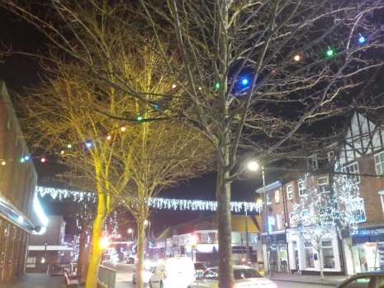
 | INCOME |  |  |  |  |  |  |  |  |  | PAYMENTS
 |  | Amount |  |  |  | Net |  |  |  |  | Service |  |  | Net
 | Approved budget | 20,000.00 |  |  |  | 20,000.00 |  |  |  |  | Installation contract |  |  | 7185.00
 | Sponsorship deals |  |  |  |  | 3286.00 |  |  |  |  | 1. Infrastructure |  |  | 9244.96
 |  |  |  |  |  |  |  |  |  |  | includes trees, electricity and wall brackets
 | Donations |  |  |  |  | 480.00 |  |  |  |  | 2. Safety tests |  |  | 3298.00
 |  |  |  |  |  |  |  |  |  |  | All wall bracket tests/columns due 2019
 |  |  |  |  |  |  |  |  |  |  | 3. Replacement and repairs |  |  | 3623.00
 |  |  |  |  |  |  |  |  |  |  | includes banners, bulbs, plaques, icicle replace
 |  |  |  |  |  |  |  |  |  |  | 4. Sundries – Cable ties etc. |  |  | 471.64
 | TOTAL |  |  |  |  | 23766.00 |  |  |  |  | TOTAL |  |  | 23,822.60 |  |  | -56.60

SPONSORS LIST
NM Residents Association | New Milton Foot Clinic | New Forest Stationers | Station Financial
Pennyfarthing | A&T | Hardys Electrical | Dixon Stewart
Double H Nurseries | New Milton Pharmacy | NMS | Cllr G Blunden
Paul Light Hair & Beauty | Charles Nobel | Weldon & King | A-Tech UK Ltd
Forest Edge Café | Bradbeers | Lions Club of New Milton | Cllr D Hawkins
New Life Church | GD Print | Kimber’s Carpets | Hoburne Bashley Holiday Park
Raise the Roots |  |  | The Wheatsheaf Inn
 | DONATIONS
NFDC Cllr Jill Cleary | New Milton Probus | Conservative Club | Cllr John Ward

