STREETSCENE ENHANCEMENT
STATION ROAD EAST & SOUTH OF MANOR ROAD JUNCTION

Following an idea from a local resident who stated that the entrance to town heading south from Fernhill Lane looked bland and neglected, it was suggested that several trees could be planted around the wide forecourt area adjacent to the Bed Shop just northeast of Manor Road. This suggestion was looked at but unfortunately the forecourt area is on private land and provides some parking for the shop as shown in the picture below.
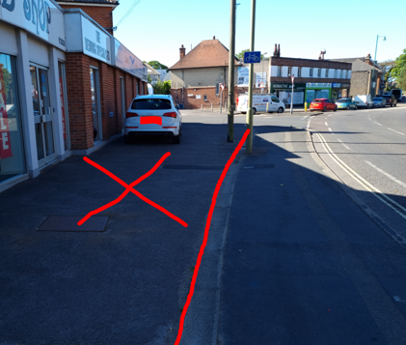
The adjacent footway is Hampshire Highway footway at this point is not wide enough to accommodate any tree planting.
However, we did look at the other side of the Manor Road junction and after an inspection an area was identified that could take two new trees and a floral planter (the trees adding structure and the planter providing most of the year-round colour.)
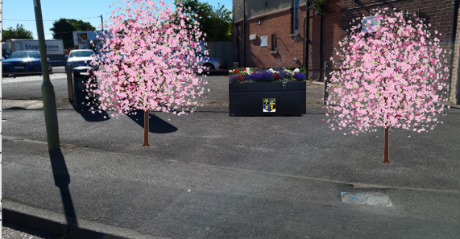
Just an example of how the area could look, trees not to scale for effect.
The planter could be of the promenade type pictured above, or tiered. There is a choice of trees that could be planted such as Lime, Silver Birch or Flowering / Wild Cherry.
Permission would need to be gained from HCC but this could be via extension of our SLA (Service Level Agreement) which currently ends at Station Road / Avenue Road junctions.
The cost to provide the trees and planter including installation would be:
- HCC opening licence (one off payment) £454.
- Provision and planting of two suitable trees £550.
- Planter with first years planting £530.
Total £1,534.
The annual costs for the planter would be £80.
The resident has kindly offered to fund the trees and the planter.
On this basis, it is recommended that the scheme be approved with the Town Council continuing the annual planting and any maintenance thereafter.

