BALLARD LAKE – WATER CONDITION
In the summer of 2021, and again throughout the dry spell this summer Ballard Lake lacked incoming run off - and rainfall to maintain adequate water levels - the depth of water in the lake reduced to around 100mm (4”) in places during the worst of the dry period.
The lake suffered because of this, with dissolved oxygen levels falling perilously low due to lack of water movement, too many fish and debris from wildfowl etc. Working closely with the Environment Agency, the estates team placed pumps in the lake to aerate and increase dissolved oxygen levels, and whilst this was generally successful, unfortunately some fish were lost.
Whilst Ballard is not a fishing lake, over a period of years fish have been placed in there and have bred increasing the stock to an unmanageable level, we therefore need to look at what possible courses of action we could take to reduce fish numbers and improve the condition of the lake. Below is a report produced for the Town Council by Paul Newman of the Environment Agency which is very useful and identifies possible actions we could take.
“During our last conversation I promised to write a line or two and provide you with some information to explain to your members the rationale behind reducing the biomass of fish, de-silting and installing a silt membrane at Ballard Lake, New Milton. I apologise in advance if the information given below is a little simplistic but, I will try to explain how these measures can eliminate the impact of prolonged dry weather events in a freshwater system as if the audience had little or no knowledge of the subject.
Ballard Lake – Management Plan
The water quality within an enclosed freshwater system, or still water, is important: it often determines the biological productivity of that water. Acidic water, as found in many of the New Forest ponds and streams, has a pH less than 7 and is normally less productive than alkaline water which has a pH greater than 7. Acidic water usually lacks certain essential chemical constituents and has lower levels of calcium. These chemicals are essential for the healthy growth of many plants, invertebrates and to effectively recycle nutrients. Acidic waters rarely harbour dense populations of aquatic invertebrates. If they do, then the invertebrates are often specialised for life in acidic environments. Most still waters are at their most productive when they are slightly alkaline, with a pH between 7.5 and 8.5. It is possible to manage the chemistry of the water within a fishery however, you should only do this as part of a wider, sustainable management plan. The first step is always to tackle the source of the problem, for example excess nutrients, silt, fish, and inappropriate fish species composition. Occasionally flowing and enclosed waters can contain excess nutrients, becoming enriched and are termed eutrophic. Nutrients can come from a variety of different sources, for example, agricultural run-off, sewage effluent, decomposing leaf litter or other organic material and large numbers of waterfowl. The latter is particularly relevant to Ballard Lake as many residents feed waterfowl with bread. Excess nutrients get locked up within layers of silt because nutrient molecules attach themselves to silt molecules. Bottom feeding fish, such as carp, release these “locked up” nutrients into the water column as they feed. Nutrient enriched water causes algae to bloom during the spring and summer months which also prevents higher plant forms from photosynthesising. Carp are omnivorous and will eat submerged higher plant forms which are essential for intercepting excess nutrients. When algae bloom, they reach extremely high numbers of individual cells, and this has a direct impact on dissolved oxygen levels often causing them drop to dangerous levels. These conditions also cause additional acidification reducing the pH and limiting productivity even further.
Sediment inputs to enclosed waters exacerbate this issue as it causes reduced water depths which in turn elevates water temperatures reducing dissolved oxygen levels even further. Warmer water holds less oxygen, and this is very important because all species of fish actually require more oxygen at higher temperatures than at low because they are poikilothermic (more active when warm, less active when cold). Some types of algae such as Blue Green Algae produce exotoxins that can be dangerous to human health and animals (including fish and dogs). Algal blooms and elevated temperatures when combined with adverse atmospheric conditions or, the cooling effect of rainfall can lead to an algal die off event and consequently large-scale fish mortalities through depleted oxygen levels. An algal die off event leads to an abundance of dead plant material (algal cells) and the micro-organisms that consume this material have a high biological oxygen demand (BOD) and use a lot of oxygen as they do so. If a low atmospheric pressure, as commonly associated with summer thunderstorms, occurs at night when the diurnal rhythm of plants causes dissolved oxygen levels naturally drop, the results can be catastrophic for many fish species. Consequently, the reverse can occur during daylight hours under warm, still and dry conditions as the algae photosynthesise, this causes oxygen supersaturation (greater than 100%) which can also be detrimental to fish populations in poor water quality environments. The dissolved oxygen level at Ballard Lake on 18/08/2022 was 136%
There are several management measures that owners and managers of still waters can take to alleviate and even eliminate the problems associated with silt, nutrients, and algae. Silt can either be removed from the system and/or prevented from entering it. Removal is always recommended if a still water is suffering from the impacts of eutrophication. Removing silt by dredging can be expensive and involves considerable preparation especially if the material is not going to reused on site (creating islands or additional marginal habitat). Disposal of any material removed can also be a concern particularly when large volumes are involved as the spoil removed will often be in the form of a liquid slurry which will need to be dried out prior to removal from site. Sediment traps or settlement ponds are also used to prevent silt entering a system. An additional pond excavated upstream of the affected pond or lake intercepts silt laden water and encourages it to drop out of solution due to the reduced flow conditions, however when a settlement pond is not maintained it also silts up and the problem is simply transferred down the system. Once a still water has been dredged, a silt curtain can also be used to intercept silt emanating from an upstream catchment. Silt curtains act in the same way as a settlement pond by slowing the flow. Designed specifically for vertical bank protection at the water’s edge, dredged material is placed behind it where it eventually dries and becomes vegetated. These geotextile membranes can also be used to good effect in situations where it is desirable to limit further deterioration and reduce the effect on water quality that silt can have. Silt curtains have a small pore size that allows water through, traps silt and makes it drop out of solution. Silt curtains are made from a geotextile material that has a series of open pockets so that 75mmɸ or 100mmɸ timber posts can be installed thus fixing it to the lakebed.
Recommendations
Ballard Lake has been experiencing the effects of eutrophication for several years with algal blooms becoming more frequent and severe. Prolonged dry weather, high sediment loads, and inappropriate fish stocks are exacerbating this issue. In more recent years this has resulted in fish in distress incidents, deployment of aeration equipment and advisory visits from the Environment Agency. The following is a list of recommendations provided by the Environment Agency’s Fisheries, Biodiversity and Geomorphology Team based in Romsey, Hampshire.
- Aeration. Without additional aeration a fish mortality at Ballard Lake is a real possibility. Solar powered aeration systems are available, relatively cheap, easy to install, very low running costs compared to fossil fuel alternatives, quiet and supplied with timers to ensure aeration at critical times of the day.
- Health status of fish at Ballard Lake. Ballard Lake is predominantly stocked with carp. It is recommended that a sample of fish is submitted for a health check. Health screening is required by law prior to fish being removed and stocked to another water.
- CEFAS Registration. Ballard Lake should be registered with CEFAS and the Environment Agency.
- Biomanipulation of fish stocks. The biomass of carp at Ballard Lake should be significantly reduced or, if possible, all carp removed. It is recommended that Ballard Lake is stocked with less damaging and more appropriate fish numbers for this size of water. Suitable species such as tench, crucian carp, rudd and perch will ensure a balanced fish community. Perch will help keep recruitment of other fish species within acceptable levels. Thinning of stocks should be carried out every 4 years to remove most smaller fish. Opening dialogue with a local fishing club could assist NMTC with this endeavour.
- Sediment levels. It is recommended that NMTC undertake a project to remove as much sediment as possible from Ballard Lake. Water depth is currently c. 6” to 8”. This situation will continue to worsen and eventually the pond will cease to function as a green asset, popular with many residents in the town. Sediment should be sampled and analysed for contaminants as this will have a bearing on its end use. Once the dredging operation is complete a geotextile membrane can be installed around the inlet to Ballard Lake. This will prolong the life of the pond, maintain water quality, and encourage higher plant forms to proliferate which will eliminate harmful algal species, lead to clear water conditions and a significantly improved freshwater environment for all to enjoy.
- Pond dipping. A pond dipping platform installed as an educational resource for local school children.
- Feeding waterfowl. The feeding of waterfowl should be discouraged. Many people feed bread; waterfowl cannot digest bread very well which leads to high nutrient levels from faecal matter. Faecal matter can also lead to Avian Botulism an obvious risk for those who use Ballard Lake recreationally. If feeding is to be allowed at this location, local shops should be encouraged to sell grain as this type of feed is readily digested by most bird species. Signage installed to educate residents as this is often a very effective preventative measure. Interpretation board installed following completion, highlighting the species that can be found in and around the pond.”
Though the report does mention possible restocking the lake with more suitable fish after initial destocking, this is course we would not want to take but in general much of what is contained in the report is relevant to improving and maintaining the quality of the lake.
Short term it is recommended that several of the fish are health checked this autumn/winter and if the results are satisfactory the lake fish stock is reduced as much as possible, this could be achieved by working with local fisheries (appropriate licences would need to be obtained).
A solar driven floating aerator will be placed on the lake powered by a solar panel on the lake island, this can be operated remotely and only on when required, this will undoubtably improve water quality.
Also based on this report further work can be carried to come up with the best options for the long-term future of the lake (de-silting etc) along with costings, this could then be brought back to committee for further discussion.
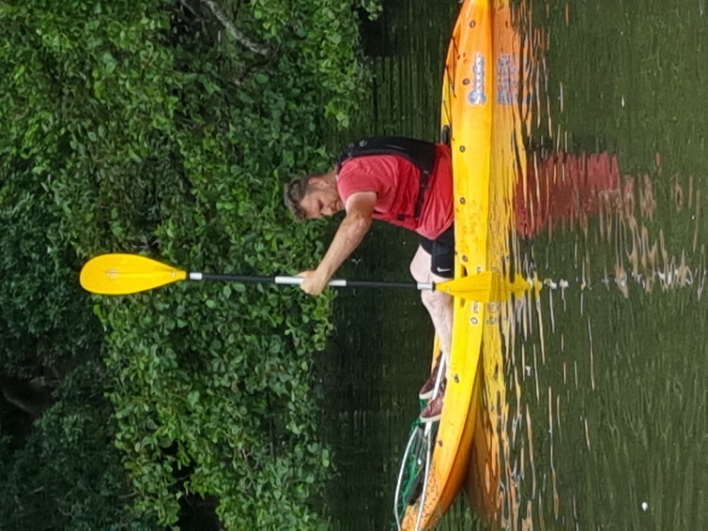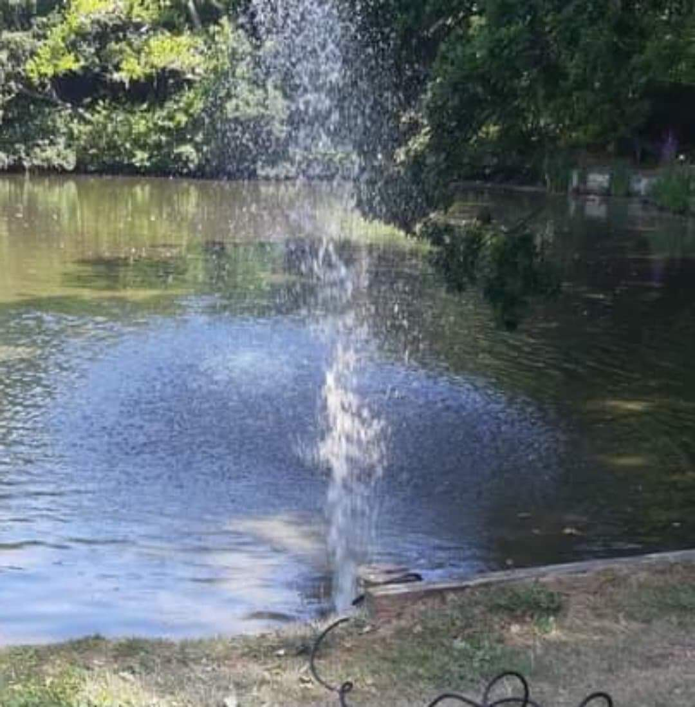
Photographs showing the depth of water left in July this year and one of the temporary pumps in action.

